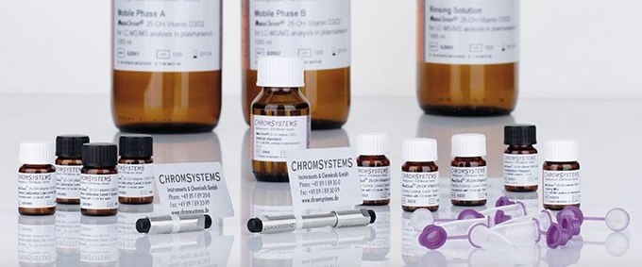
- Isotopically labelled internal standard
- Multilevel calibrators
- Online sample preparation
- Upgrade available for the dermination of 3-epi-25-OH-Vitamin D3/D2
Vitamin D has been widely recognised as a biomarker in relation to osteoporosis and osteopenia. It has also been shown to play a prominent role in immune response, cardiovascular disease and certain types of cancer. Vitamin D analysis, therefore, carries significance in several respects.
25-OH-vitamin D3 constitutes the principal diagnostic target and is the main metabolite of vitamin D in humans; it is the precursor of the physiologically most active compound 1,25-(OH)2-Vitamin D3. Vitamin D deficiency is treated with vitamin D3 or vitamin D2 supplementation. Vitamin D2 is easier to produce synthetically and, where prescribed, its monitoring is also necessary.
This reagent kit allows for the specific analysis of 25-OH-vitamin D3 and 25-OH-vitamin D2 in serum and plasma by tandem mass spectrometry. Manual sample preparation is minimised and limited to simple and effective protein precipitation. A subsequent online trap column concentrates the analytes and separates interfering substances. A six-port-valve connects the trap column to an HPLC column which provides further purification. The use of atmospheric pressure chemical ionisation (APCI) and an isotopically labelled internal standard assures precision and robustness and minimises ion suppression effects. The 3PLUS1® multilevel calibrators offer additional precision.
The upgrade to MassChrom® 25-OH-vitamin D3/D2 analysis allows for the separation of the main metabolites of vitamins D3 and D2, 25-Hydroxycholecalciferol and 25-Hydroxyergocalciferol, from their epimeric forms 3-epi-25-OH-vitamin D3 and 3-epi-25-OH-vitamin D2, hence allowing for separate quantification by LC MS/MS.

