PIK3CA (E542Q)
Catalog Number: 26210
Gene Symbol: PIK3CA, CLOVE, CWS5, MCAP, MCM, MCMTC, PI3K, p110-alpha
Description: Anti-PIK3CA (E542Q) Mouse Monoclonal Antibody

Background:
Phosphatidyl 3-kinases (PI3K) are a family of lipid kinases involved in many cellular processes, including cell growth, proliferation, differentiation, motility, and survival. It is composed of an 85 kDa regulatory subunit and a 110 kDa catalytic subunit. Mutants of PIK3CA has been found in the pathogenesis of several cancers, including colon cancer, gliomas, gastric cancer, breast cancer, endometrial cancer, and lung cancer.
Immunogen: A synthetic peptide from the internal region of PIK3CA which includes the mutation of E542Q, human origin.
Tested applications: ELISA, WB, IHC
Recommended dilutions:
ELISA: 1:1000-1:5000
WB: 1:500-1:1000
IHC: 1:50-1:100
Concentration: 1 mg/ml
Host: Mouse
Clonality: Monoclonal
Purity: Purified from ascites
Format: Liquid
Storage buffer:
Preservative: no
Constituents: PBS (without Mg²⁺ and Ca²⁺), pH 7.4, 150 mM NaCl, 50% glycerol
Species Reactivity: Recognizes E542Q mutant, but not wild-type PIK3CA of vertebrates.
Storage Conditions: Store at -20°C. Avoid freeze / thaw cycles.

Western blot:
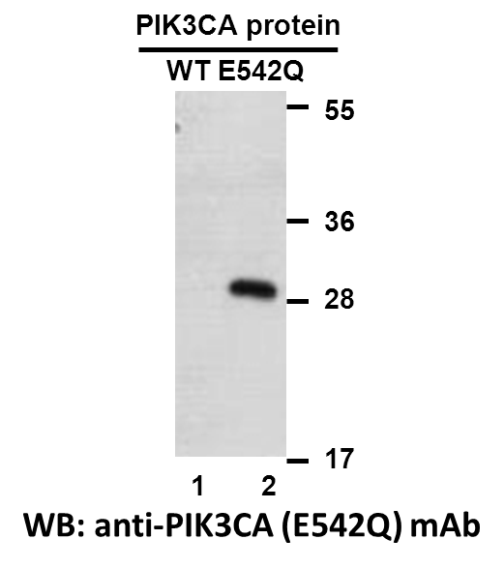
Western blot analysis of recombinant PIK3CA (E542Q) and wildtype proteins. Purified His-tagged PIK3CA (E542Q) protein (lane 2) and corresponding wildtype protein (lane 1) were blotted with anti-PIK3CA (E542Q) monoclonal antibody (Cat. #26210).

Immunofluorescence:
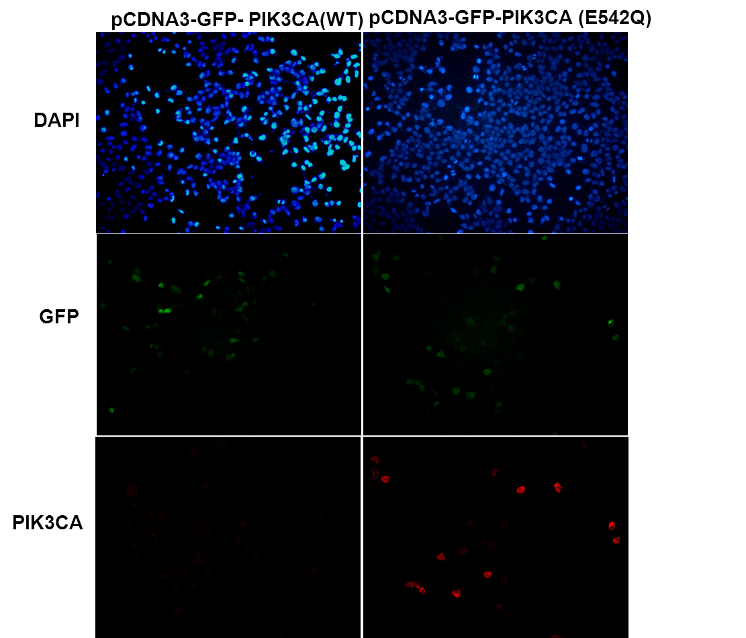
Immunofluorescence of cells expressing PIK3CA proteins with anti-PIK3CA (E542Q) antibody. HEK293T cells were transfected with pCDNA3-GFP-PIK3CA (WT) plasmid (left column) or pCDNA3-GFP-PIK3CA (E542Q) plasmid (right column), then fixed and stained with anti-PIK3CA (E542Q) monoclonal antibody (Cat. #26210).

