Exosome-Depleted FBS
Get the cell culture performance you demand without compromising your results
An ultrapure FBS that provides the highest level of exosome depletion and cell culture performance available
Fetal bovine serum (FBS) is a major ingredient needed for culturing cells. However, it naturally contains high levels of endogenous exosomes, which interfere with the study of exosomes derived from cultured cells. We have developed a complex manufacturing process that eliminates ≥90% of the endogenous exosomes from FBS, while not compromising cell growth. Now you can reduce background signal, isolate highly pure exosomes secreted by cells, and eliminate guessing whether your homemade exosome-depleted FBS is performing the way you want it to. Want to spend more time generating results rather than questioning them? Gibco™ Exosome-Depleted FBS has the highest level of exosome depletion compared to homebrewed material and competitor FBS (Figure 2)—and it performs without compromising cell growth (Figure 3).
Lot-to-lot consistency from the recognized leader in quality We test every lot of our new Exosome-Depleted FBS for exosome depletion and culture performance, in addition to the strict quality control procedures we already perform on all of our FBS.
Lot-to-lot consistency from the recognized leader in quality
We test every lot of our new Exosome-Depleted FBS for exosome depletion and culture performance, in addition to the strict quality control procedures we already perform on all of our FBS.
Reduce variability and improve results every time with the best-performing exosome-depleted FBS available, offering:
• ≥90% depletion of exosomes, highest level of depletion on the market • Complex manufacturing process that retains the nutrients your cells need • Cell culture testing of every lot • Full quality testing including: sterility, mycoplasma, performance and endotoxin • Specially developed for exosome research

“I was able to culture my cells and get very good growth in only 2.5% serum, compared to 10%, due to Gibco Exosome-Depleted FBS, maintaining a lot of the important nutrients (‘the good things’) that were lost during ultracentrifugation.” (see Figure 1 for supporting data)
Dr. Jonathan Gilthorpe Pharmacology and Clinical Neuroscience Umeå University, Sweden
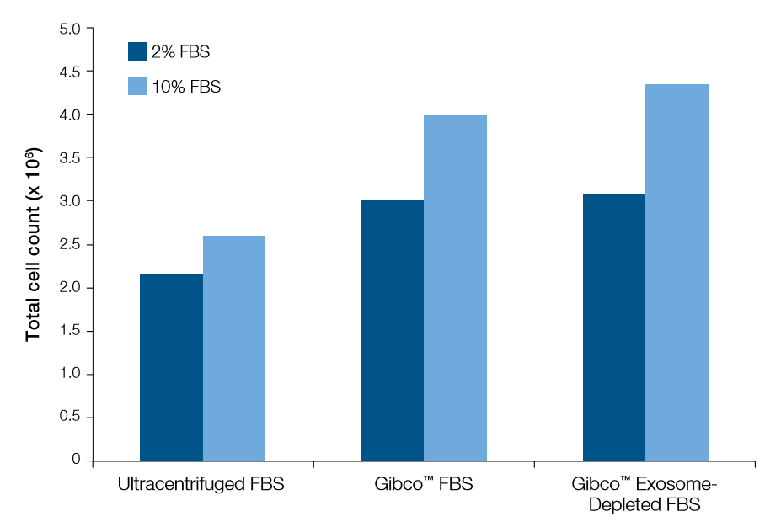
Figure 1. 72-hour cell growth of rat oligodendrocyte cells with FBS. Rat oligodendrocyte cells were seeded at 1,000 cells/well in 96-well plates, and grown in medium containing 2% or 10% by volume of one of the following supplements: Gibco Exosome-Depleted FBS (Cat. No. A2720801), source Gibco™ FBS (Cat. No. 26140-079) or ultracentrifuged FBS. After 72 hours in culture, the cells were stained live with Hoechst 33342 (Invitrogen™ Molecular Probes™ Cat. No. H3570), and the plate was imaged and analyzed on a 96-well plate imaging instrument (Trophos PlateRunner HD). Results are presented as the total cell counts as reported by the 96-well plate analysis. (The results were obtained from the laboratory of Dr. Jonathan Gilthorpe in the Department of Pharmacology and Clinical Neuroscience at Umeå University, Sweden.)
Ordering information
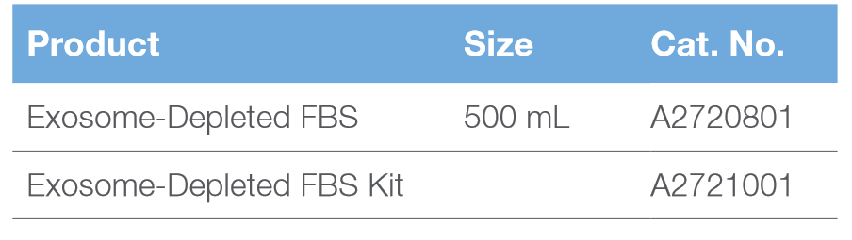
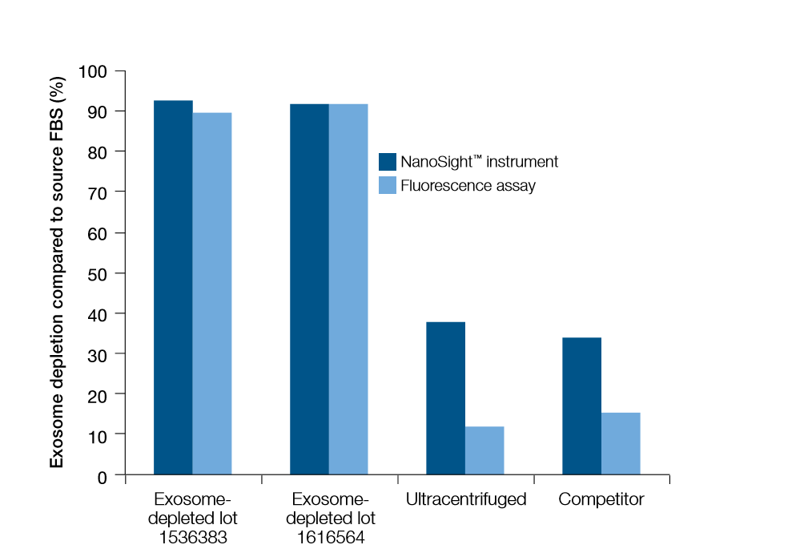
Figure 2. Exosome depletion from FBS samples, as verified by two different methods. Exosome depletion was verified by analysis on a NanoSight™ instrument (comparing the 30–150 nm count before and after exosome depletion) as well as by a fluorescence-based assay. Briefly, this assay involves extracting exosomes using Invitrogen™ Total Exosome Isolation Reagent (from serum) (Cat. No. 4478360), and then staining the isolated exosomes with Invitrogen™ Molecular Probes™ BODIPY™ TR Ceramide (Cat. No. D-7540). The first two exosome-depleted lots shown above were produced by our proprietary method. Also included were an ultracentrifuged sample and a competitor’s product.
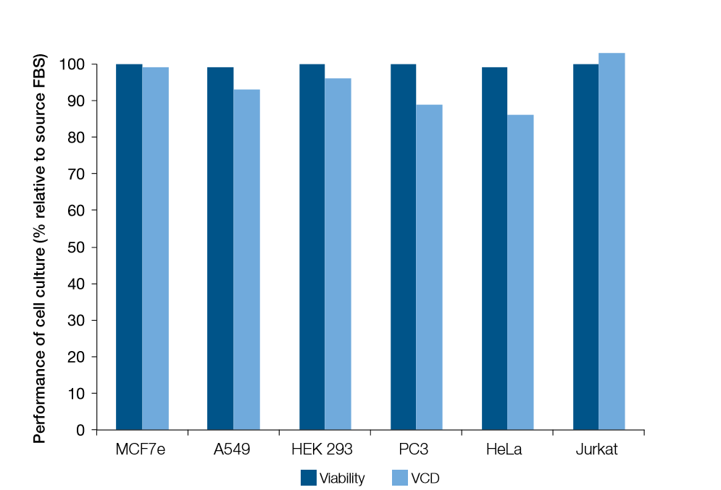
Figure 3. Two-day viability and viable cell density in cell cultures containing exosome-depleted vs. source FBS. Cell lines were grown in basal medium (Gibco™ DMEM, high glucose, GlutaMAX™ Supplement; Cat. No. 10566-016) containing 10% Exosome-Depleted FBS or source FBS, and then assayed for cell viability and viable cell density (VCD) on a ViCELL™ instrument. Results are presented as the viability or VCD that was achieved with Exosome-Depleted FBS as a percentage of that achieved with the undepleted source FBS.

http://www.thermofisher.com/cn/zh/home/life-science/cell-analysis/exosomes.html?cid=fl-exosomes -外泌体研究产品

北京统计公司：北京细工生物科技有限公司
统计邮箱：procyte@126.com
统计项目：SBI QIAGEN 外泌体试剂盒提取实验结果。

